CAUSAL INTERPRETABILITY OF A ROBOT POLICY
Where does π0.5 keep the instruction it is following?
A five-page plain-English report on the project's lineage, experiments, evidence, failures, and safety relevance.
What question did you try to answer?
When π0.5 turns a sentence and camera view into a movement, where does the instruction's causal influence go? We looked for a small internal object—a direction, token-local code, low-rank subspace, or compact pathway—that could be changed without replacing the rest of the scene and motor state.

Why is the question interesting?
Language-model interpretability often starts with semantic tokens. A robot must mix language with pixels, pose, and control constraints before it acts. Its decision may live in a private coordinate system that is not readable as words. The setting also supplies unusually hard validation: same scene, different valid command, followed by action distance, first object touched, and task success.

What conclusions did you reach?
The instruction is used during multimodal prefill. Later, its text-token copy remains readable but has little control over the tested Goal actions. Broad late image-position state can redirect behavior, including 18/20 closed-loop successes versus 0/20 for an early-layer control. Compact descriptions failed, but a full layer-6→8 update transferred across initial scenes and required the MLP sublayers. Decoding, causal use, and token provenance separate after modalities mix.

Headline | Verified result | Plain-English meaning
Causal handoff | Text K/V R=0.0106; late image K/V R=0.8321 | The readable instruction and the action-controlling state are not in the same place.
Behavior | Late live repair 18/20; early control 0/20 | The broad state changes complete robot behavior, not only one vector.
Compression | Object-local 0/8; Sonar endpoints 0/12 | A selective, portable instruction feature was not isolated.
Main organism: π0.5 LIBERO checkpoint. Boundary test: OpenVLA-OFT. Evidence is scoped to the archived tasks and checkpoints; it is not a universal claim about all VLAs.

ORIGINS
From Othello-style coordinates to physical action
The project changed organisms, not its core concern: how to audit a decision that exists inside a learned latent state before it becomes visible behavior.
Commit | Project move | Reason
1e080c1 | JEPA/world-model causal forensics | Try to implant and locate a false physical rule.
ca3b272 | Pivot to VLA instruction locus | The world-model organism lacked a validated behavioral effect; π0.5 + LIBERO had one.
32285db | Reader-facing framing | Make the same-scene instruction conflict and causal test legible.
2bfafb9 | Suite qualification | Correct an overclaim after Goal and Object results differed.
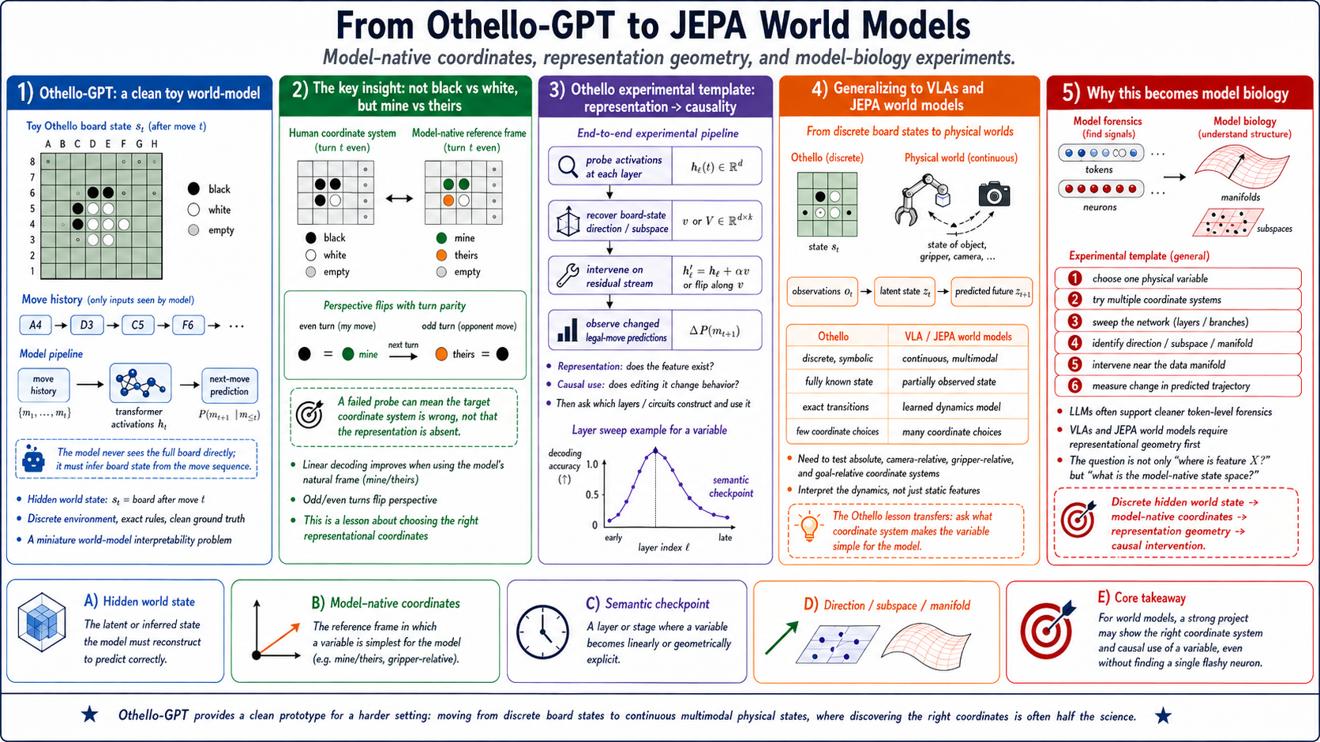 | 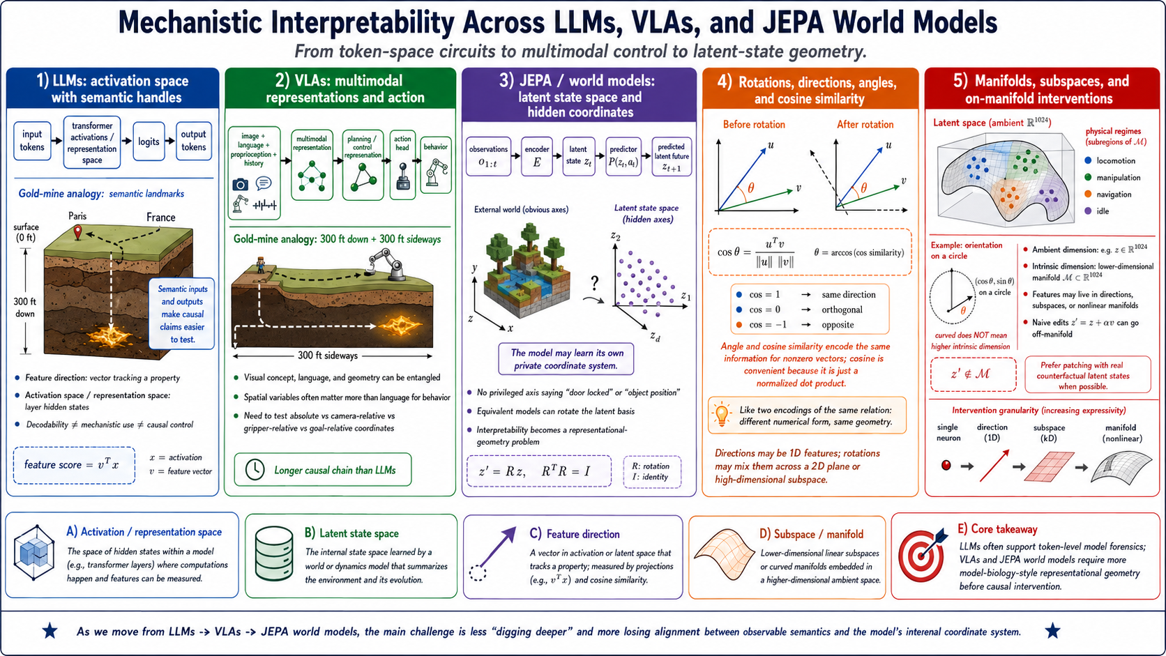 | 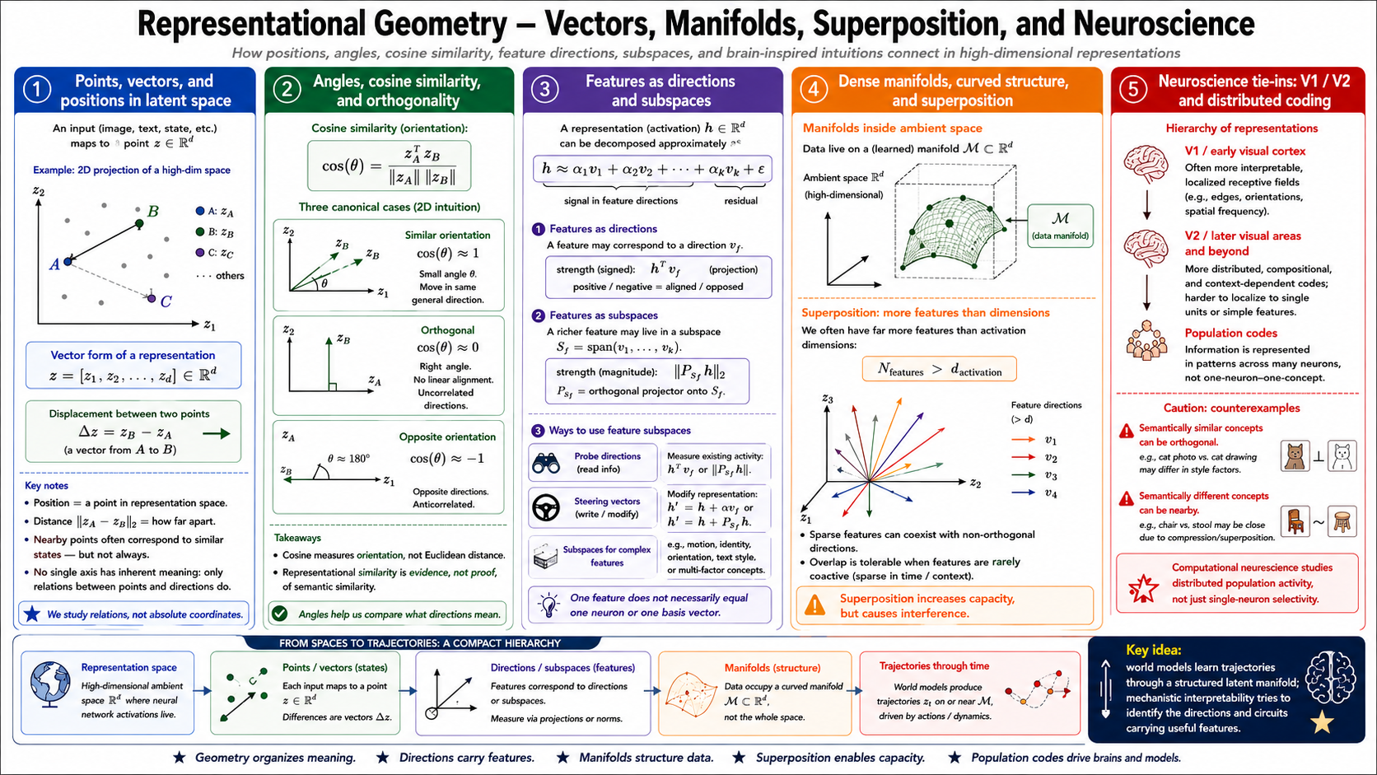
Conceptual lineage (left to right): model-native coordinates; the longer LLM→VLA→world-model causal chain; directions, subspaces, superposition, and manifolds. These diagrams motivate tests; they are not result figures.
The Othello lesson was that a human label can be the wrong coordinate. “Black versus white” is less natural to the model than “mine versus theirs,” which flips with the turn. A VLA has more possible coordinate systems: camera-relative, gripper-relative, object-relative, goal-relative, and combinations of them. This is why a direction learned in one scene may fail in another without the information disappearing.
The first plan used a JEPA-style MetaWorld predictor with a deliberately false door rule. It never reached the intended interpretability experiment: the checkpoint and paired counterfactuals were not validated, and the planner produced 0/120 elite inaction samples. The pivot to a released VLA kept the latent-state safety question while giving us a working organism and objective behavior.
The Plato's-cave intuition from Beyond Language Modeling also survives in a modest form. Text describes the physical world; it is not the world. In π0.5, a linguistic instruction becomes part of a multimodal state whose function is better described by the action it causes than by the token type at its storage position.

WHAT WE DID
A ladder from behavior to causal mechanism
Each step asked a stronger question. Positive internal geometry was never treated as enough without an action or rollout test.
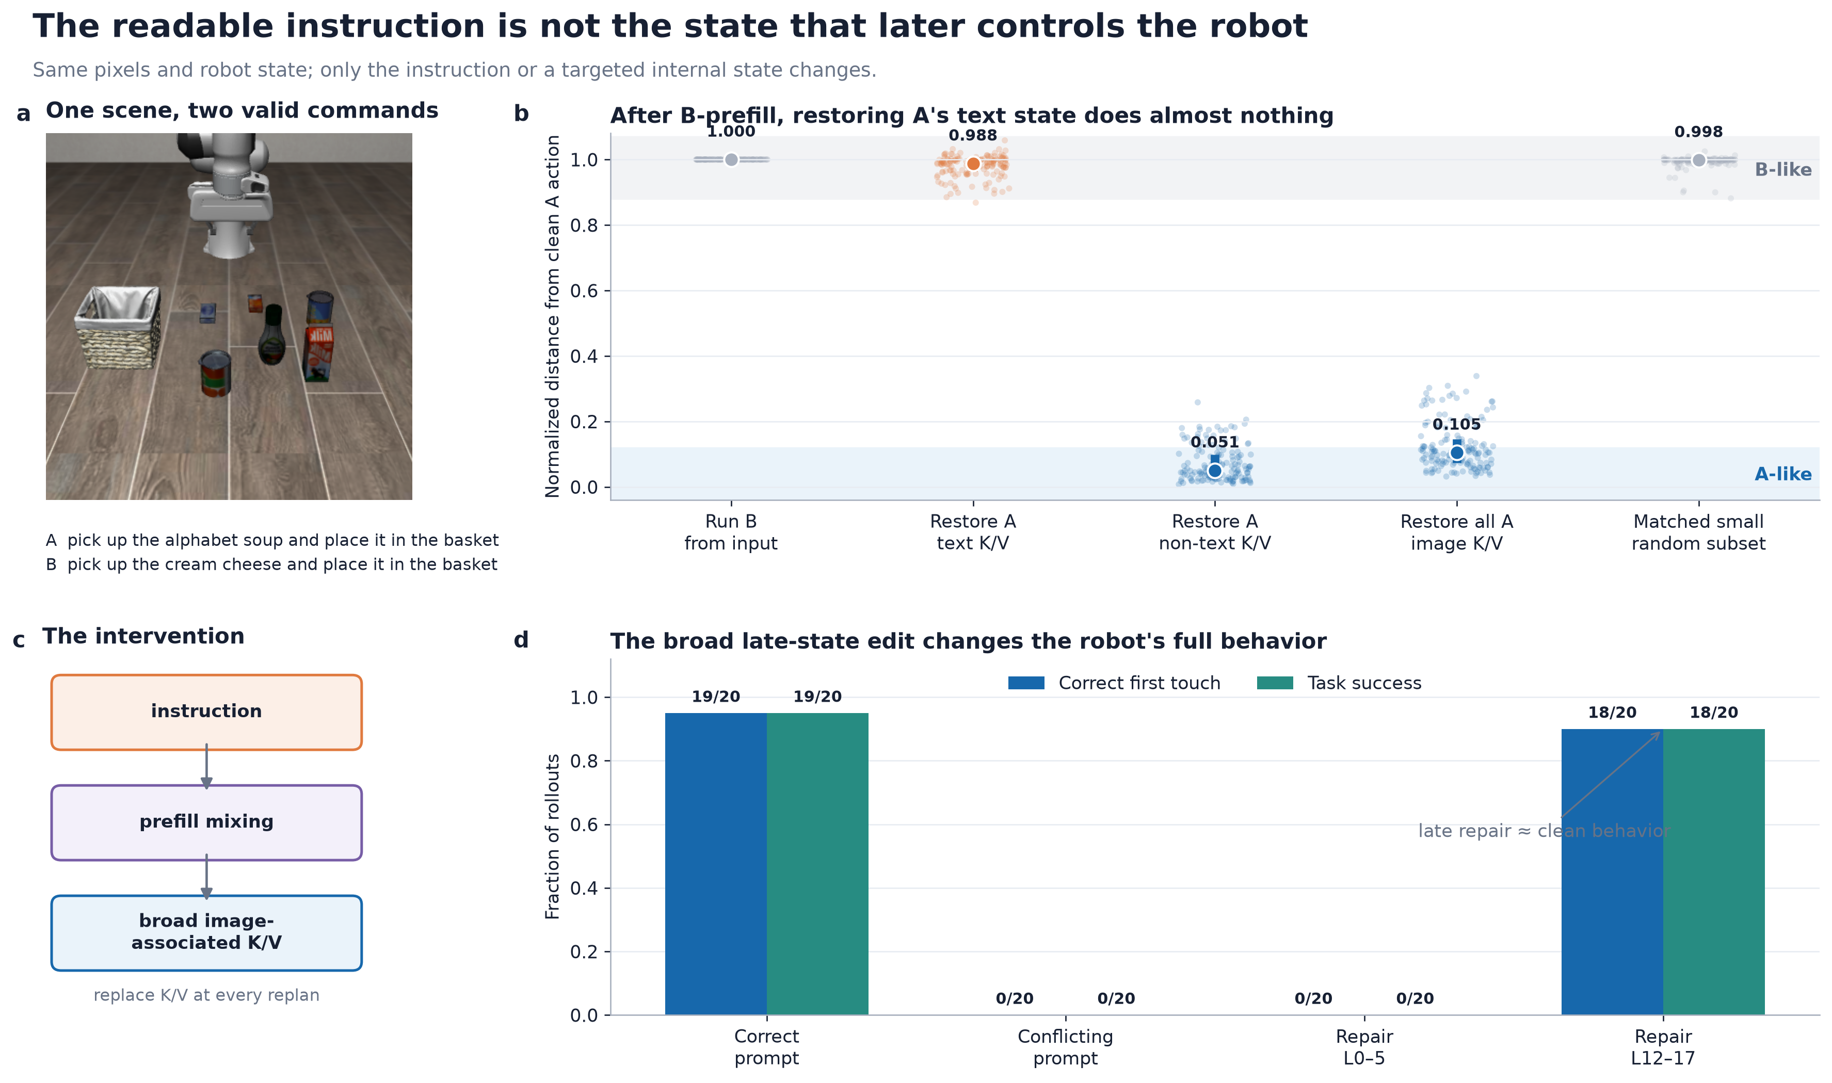
Figure 1. Same pixels and robot state, two valid instructions. Broad late image-state replacement redirected closed-loop behavior; the early-layer control did not.
Stage | Direct test | Main finding
Behavior | Conflict the benchmark goal with another valid command | Obedience became measurable by first touch and success.
Readout | Probe each layer and inspect attention | Instruction identity remained readable at text positions.
Causality | Patch text, image, and other prefix state | Late image state, not late text state, carried most Goal action control.
Timing | Swap instruction before prefill; repair state after | The instruction is used early, then its consequence is distributed.
Behavioral validation | Repeat the patch at every replan | Late repair completed 18/20 tasks; early control completed 0/20.
Compression | Patch object tokens, position doses, directions, subspaces | No small portable representation matched the whole-state effect.
Communication | Block and rescue instruction→image and image→action edges | The broad route was necessary; compact writer rescue failed.
L6–8 computation | Curvature, then full/attention-only matched-scene tests | The path bent; only the natural full-block update transferred across scenes.
Stimuli and controls.
- LIBERO Goal and Object tabletop scenes; A/B prompts were token-position matched where an intervention required it.
- The observation, robot state, action noise, and prompt formatting were held fixed; only the task instruction changed.
- Self-patches, wrong prompts, early/dead layers, equal-count random positions, norm-matched random directions, reversed signs, and distances to both clean endpoints guarded against silent no-ops and model damage.

EVIDENCE
What the main numbers actually measure
The central result is a mismatch between where information can be read and where an intervention changes behavior.
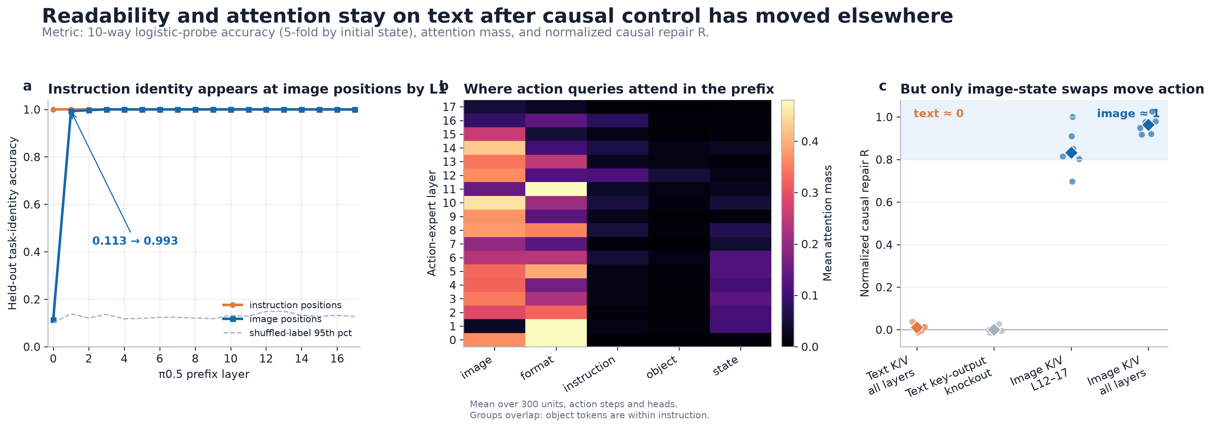
Figure 2. Layerwise decoding, attention, and causal repair answer different questions. “Probe accuracy” is 10-way grouped cross-validated classification accuracy—not a correlation coefficient.
Metric | Definition | Headline result
Probe accuracy | 10-way multinomial logistic regression; 5 folds grouped by initial state | Text 1.000 at L0–16; image 0.113 at L0 → 0.993 at L1.
Repair R | Progress from source toward donor action, with endpoint distance checks | Text K/V 0.0106; late image K/V 0.8321.
Endpoint distance | D_A and D_B are L2 distance divided by clean A–B distance | Broad carrier D_B=0.2349; dose-256 D_B=0.9260; dose-512 D_B=0.2564.
Behavior | First intended object touched; simulator task success | Conflict 0/20; late repair 18/20; early repair 0/20.
Attention mass | Action-query mass per prefix segment; both total and per-token | Text/image 11.41× per token; image/text 4.99× in total.
Monitor F1 | Outcome classifier versus constant positive baseline | Dev 0.909; held instruction 0.681; held scene 0.745; baseline 0.801.
Curvature/chord | Midpoint deviation divided by endpoint-output chord | Median 0.188; 12/12 cell medians ≥0.1.
Curvature action | Action change after linearization divided by endpoint action distance | Median 0.0973; 5/12 ≥0.1; preregistered fail.
Cross-model Dsrc | Distance from patched action to donor, normalized by endpoints | OpenVLA-OFT instruction 0.0101; image 0.9574.
Sample size discipline: the inferential unit was the directed prompt-pair or scene-condition cell. Repeated rollouts and five initial states were replicates inside a cell. Treating all raw rows as independent would manufacture confidence because many repeated rollouts are identical or highly dependent.

WHAT SURVIVED
A real handoff—and strong evidence against the simple story
The project is most informative when the positive and negative evidence are kept together.
Matched layer-6→8 test
Across 12 directed prompt-pair cells, median A→B action-axis progress was 0.340 for the matching full attention+MLP message, 0.211 for the norm-matched message from another scene, and 0.040 for the matching attention-only message. Other-scene full beat random in 12/12 cells (exact sign p=0.00049), and full beat attention-only in 12/12 (p=0.00049). Matching-scene messages were somewhat stronger than other-scene messages, but only 9/12 signs agreed (p=0.146): shared computation with suggestive scene modulation, not clean scene specificity.

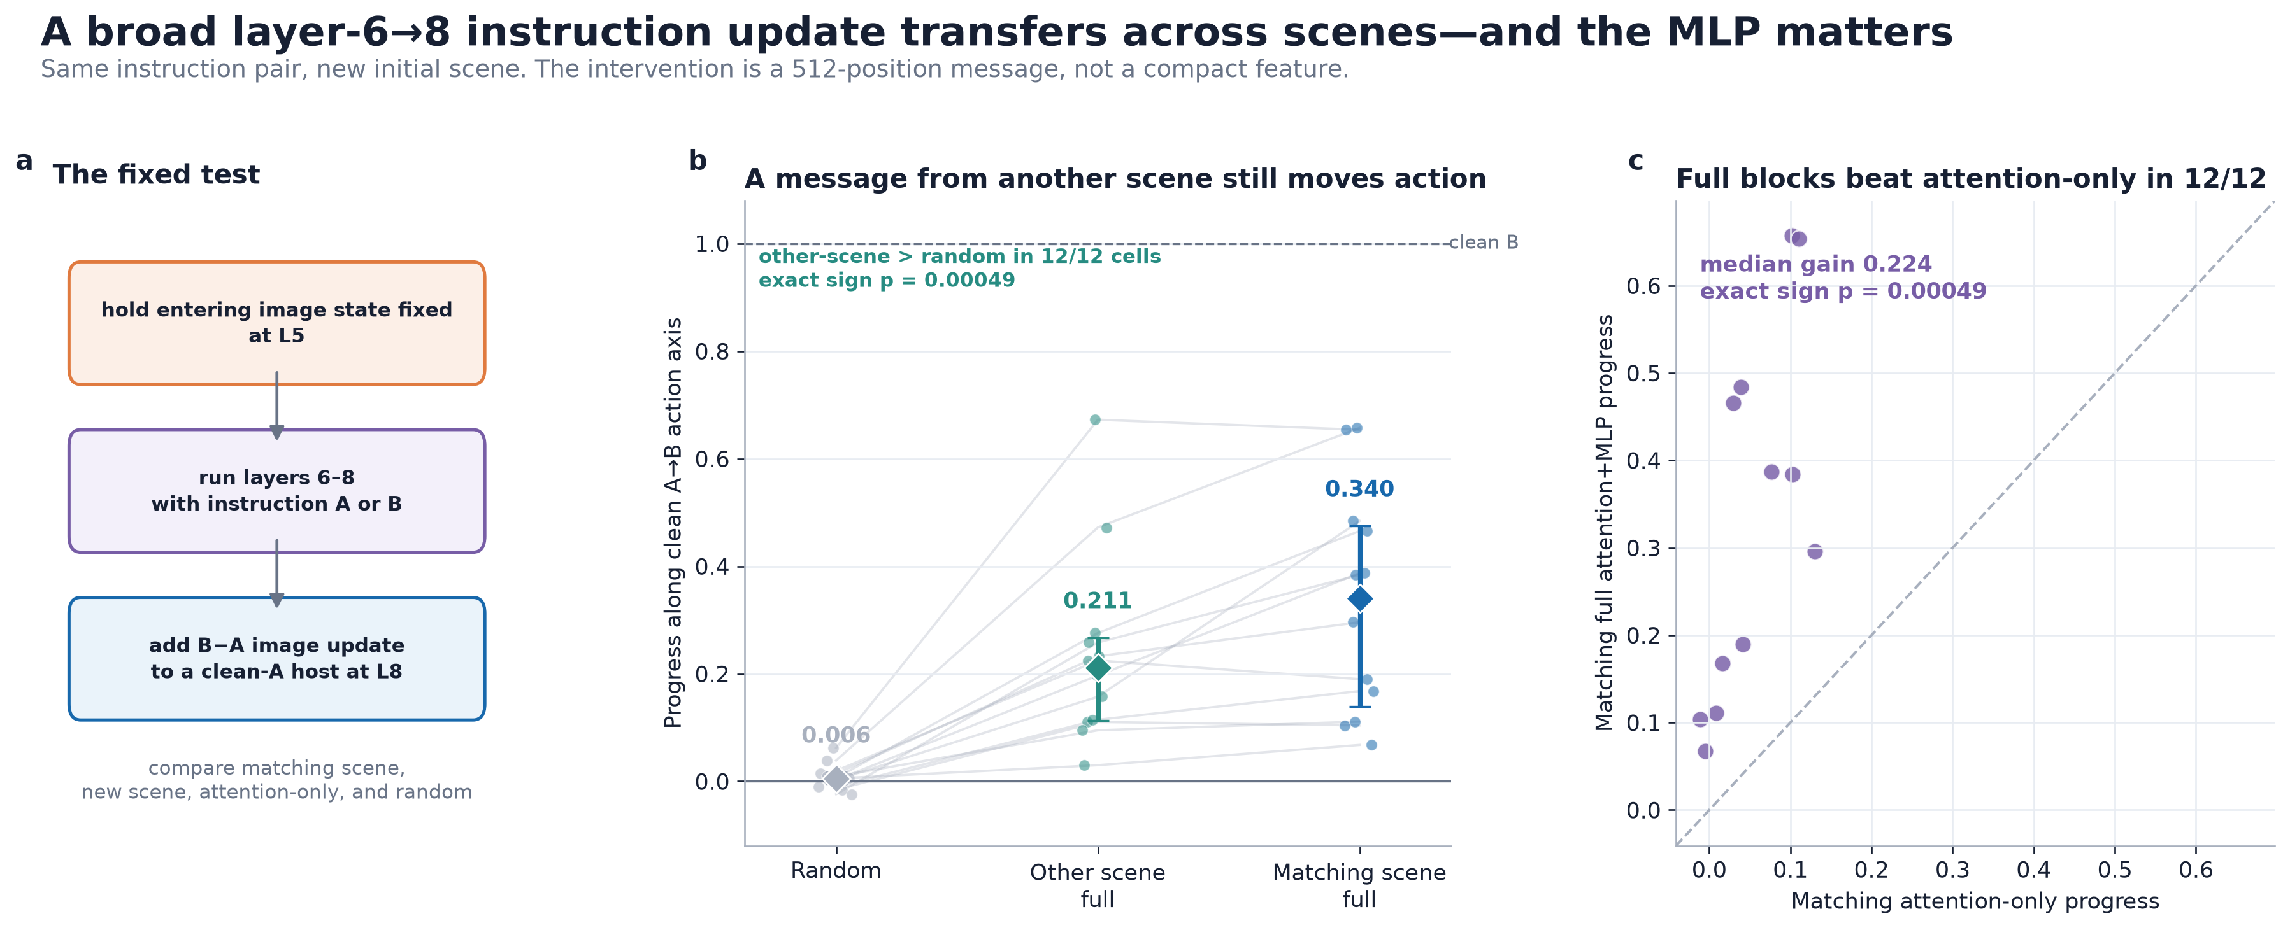
Figure 3. A full instruction-induced update transfers across initial scenes within a prompt pair, while MLP-clamped attention-only updates are weak. Dots are 12 directed cell medians.
Hypothesis | Evidence against it
The instruction stays causally at text positions | Text remains decodable, but post-prefill text repair is near zero; prefill swaps show it was used earlier.
The causal state is object-local | Object-local replacement worked in 0/8 directions; 4–256 image positions were weak relative to all 512.
One portable direction is enough | A static vector produced 5/5 correct first touches in one task but 0/5 successes and failed the two-task gate.
A low-rank subspace is the mechanism | Rank-16 Sonar fit beat controls in 12/12 cells but reached 0/12 joint endpoints; donor-free repair was 0/30.
One compact writer seeds the state | Full instruction→image blocking was A-like in 12/12, but block-0 rescue and fixed L6–8 rescue failed.
Observed nonlinearity controls action | Curvature was real, yet removing it missed the frozen causal gate.
Why this matters for safety.
A monitor can read a stale copy of the instruction while missing the state that controls motion. A broad edit can make a robot touch the intended object while damaging the later trajectory. As learned policies and world models move into robots and vehicles, interpretability needs external behavioral validation and collateral-damage tests—not only probes, attention maps, or attractive latent-space plots.
Limitations and what could have helped.
- The strongest repair is donor-assisted and replaces a large state. A learned conditional intervention needs true prompt-pair holdout and closed-loop preservation controls.
- The 8-edge reader result is development-only; it should not be called a confirmed circuit. The donor-free run is incomplete at 250/400 planned rows.
- Two checkpoints do not establish a VLA taxonomy. More models, training regimes, embodiments, and naturally occurring failure modes are needed.
- A future world-model study should begin with a released checkpoint and validated behavioral error before searching latent coordinates.
Bottom line: π0.5 contains a causally important language→multimodal-state→action handoff. We localized the broad state and changed behavior, but did not isolate a small reusable mechanism. That negative boundary is scientifically useful because it shows exactly where standard linear-feature and token-local stories stopped predicting causal control.

